Make Unusual Finger Puppets
http://www.favecrafts.com

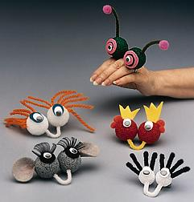
Materials:
- STYROFOAM Brand Products:
  - 2- 1" or 1-1/2" balls
  - 1- block (optional)
- 1- 3" piece of chenille stem
- 1- pair wiggle eyes
- Craft paint stiff paint brush
- Felt scraps
- Craft materials such as eyelash curls, pom-poms, yarn
- General Tools and Supplies:
- Scissors
- Craft glue or glue gun and glue sticks
- Wooden skewers or toothpicks
Instructions:
- If desired, paint balls of STYROFOAM. Push a skewer into the balls to hold while painting; place skewers in a block of foam to hold while balls dry.
- Shape 3" piece of chenille stem into a "U". Dip ends in glue and insert U shape into 2 balls so U shape will slip under the wearer's middle finger while the two balls sit on top of the hand to form the puppet's eyes. (1" balls work best for smaller hands.)
- Cut felt shapes for eyes; glue wiggle eyes to felt or attach wiggle eyes directly on plastic foam balls. Glue on other features such as pom-poms and eyelash curls, or felt ears and eyelids.
- Dab glue onto foam and use a skewer to push materials such as yarn into the foam for hair. Insert chenille stems into foam for antennae or eye lashes. For antennae, gently curve chenille stems and glue pom-poms onto the tips of shaped chenille stems; dip in glue and insert into foam.
- Modify the finger puppet instructions to create a finger friend that resembles your school mascot, favorite pet or other character. Buttons, sequins or glitter are other objects that might inspire your creativity.

